GNR644 REMOTE SENSING FOR SURFACE WATER RESOURCES
GROUP 2
ROLL NUMBER | NAME
25M0304 | SATYENDRANATH KAR
25M0611 | RISHI GANESH L
25M0612 | JAGU MANISH
25M0614 | MINTI JASAKIYA

STUDY AREA: Peninsular India
DATA PROCESSING AND VISUALIZATION:
The variables used for water budget analysis have been downloaded from the relevant sources as mentioned in Table 1.
Table 1 - Source of data for Water Budget Variables
VARIABLE | SOURCE OF DATA | RESOLUTION
PRECIPITATION | GPCP | 0.5
SOIL MOISTURE | ESA CCI | 0.25
EVAPOTRANSPIRATION | GLEAM | 0.1
GROUNDWATER | GRACE | 0.5
RUNOFF | ERA5 | 0.25

All datasets were resampled to a 0.25° spatial resolution using the Nearest Neighbour interpolation method to ensure consistent and comparable analysis across datasets.
For Groundwater data, for each month, the values range approximately between −30 cm and +30 cm. Negative values indicate water storage below the baseline mean. In April and May 2002, values were predominantly below 0 cm. From August to December, groundwater levels increased, reaching approximately 20–25 cm above the baseline. A similar pattern was observed in 2003, with water levels below the baseline from January to July and an increase from August to December. This seasonal trend continued consistently until 2014. From 2015 onward, a considerable amount of data is missing, particularly in 2017 and 2018. However, the available data indicate that the seasonal trend remained similar. From 2019 to the end of the study period (2024), the same seasonal pattern is again evident.
For visualization purposes, for each variable, monthly mean maps have plotted along with Mann Kendall Trend Analysis, which is trend analysis is a non-parametric statistical test used to detect the presence and direction of a monotonic trend (increasing or decreasing) in a time series without assuming normal data distribution.

Precipitation:
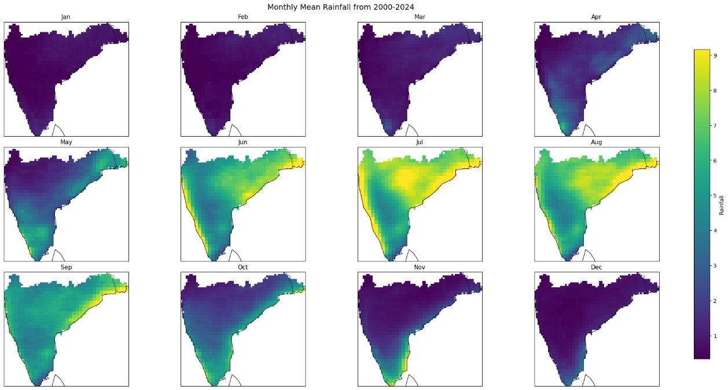
Figure 1 – Monthly Mean Maps of Precipitation
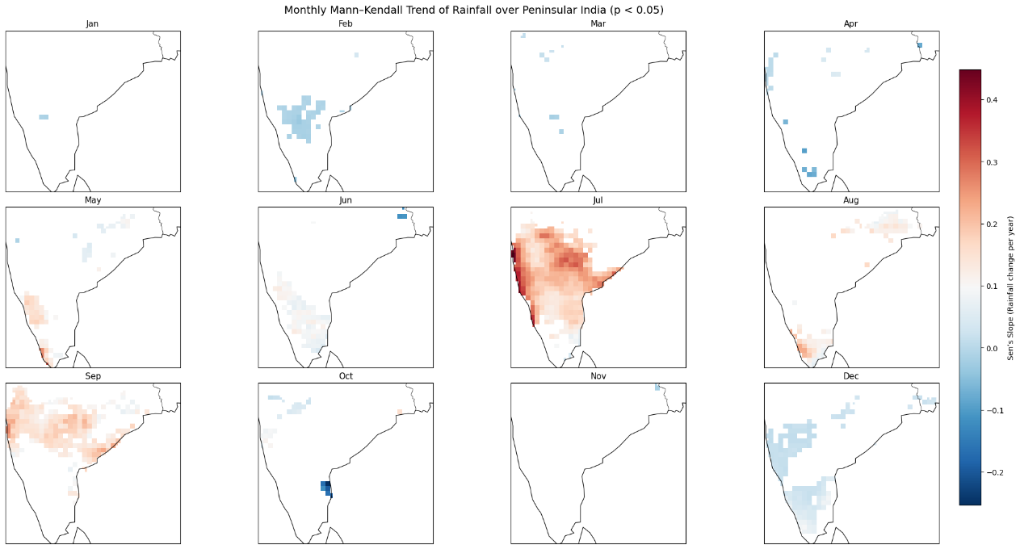
Figure 2 – Mann Kendall Mean Maps of Precipitation
Rainfall climatology over Peninsular India reflects strong monsoon dominance, with peak precipitation during June–September, intensified along the Western Ghats due to orographic uplift and followed by a post-monsoon shift toward the southeastern coast. The Mann–Kendall analysis (2000–2024) indicates that significant rainfall trends are largely concentrated in the southwest monsoon season. Dry-season months (January–April) show minimal significant change, while May and June exhibit weak, scattered trends. July demonstrates widespread positive trends across central and western regions, with additional increases in September. August shows limited change, and post-monsoon months display mixed or localized declining trends, highlighting seasonally concentrated rainfall intensification.
Evapotranspiration:
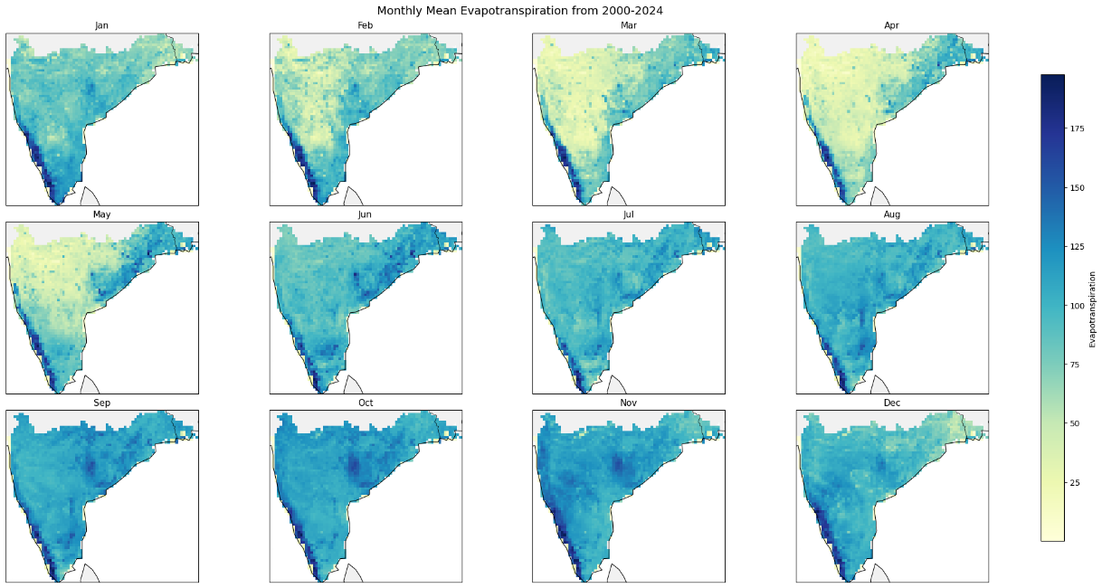
Figure 3 – Monthly Mean Maps of Evapotranspiration
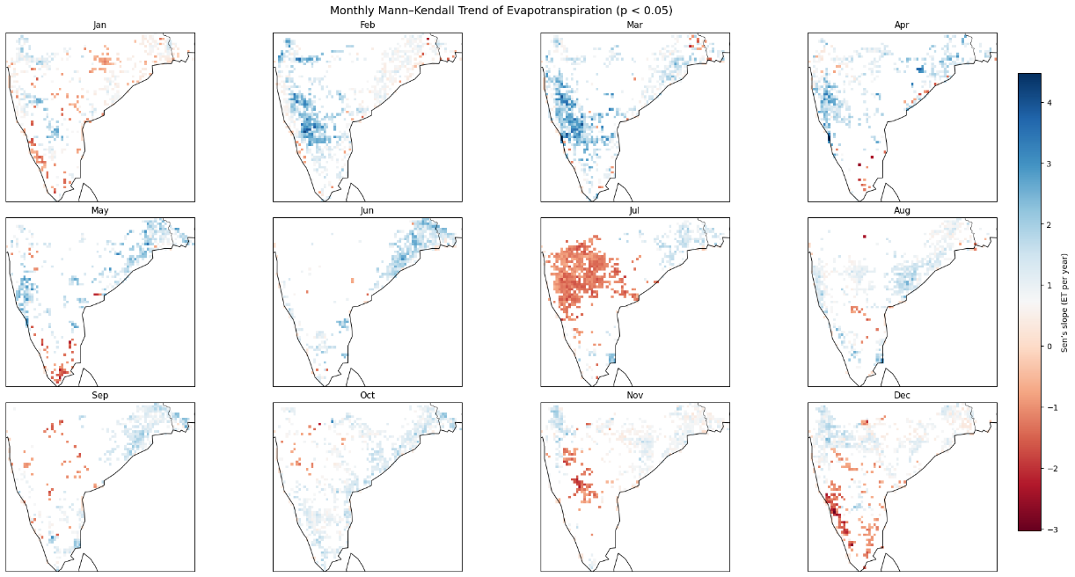
Figure 4 – Mann Kendall Mean Maps of Evapotranspiration
Monthly evapotranspiration (ET) exhibits a pronounced seasonal cycle governed by radiative forcing and monsoon-driven moisture availability. Pre-monsoon enhancement (April–May) reflects energy-limited to moisture-constrained transitions. Peak monsoon months sustain elevated ET under adequate soil moisture but moderated net radiation. Post-monsoon decline corresponds to reduced insolation and progressive soil moisture depletion. The Mann–Kendall analysis (2000–2024) indicates mostly weak and heterogeneous trends during January–May. A pronounced negative trend appears in July across the interior peninsula, suggesting reduced ET during peak monsoon conditions. August and September show mixed but generally weak signals. Post-monsoon months (October–December) display more consistent negative trends over southern and southwestern regions, indicating declining ET during the withdrawal and early dry season.
Soil Moisture:
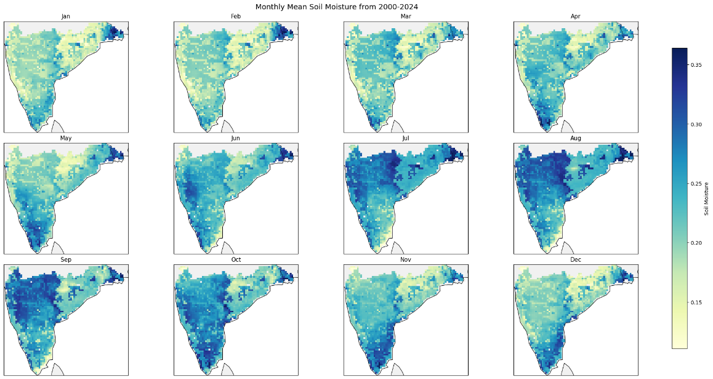
Figure 5 – Monthly Mean Maps of Soil Moisture
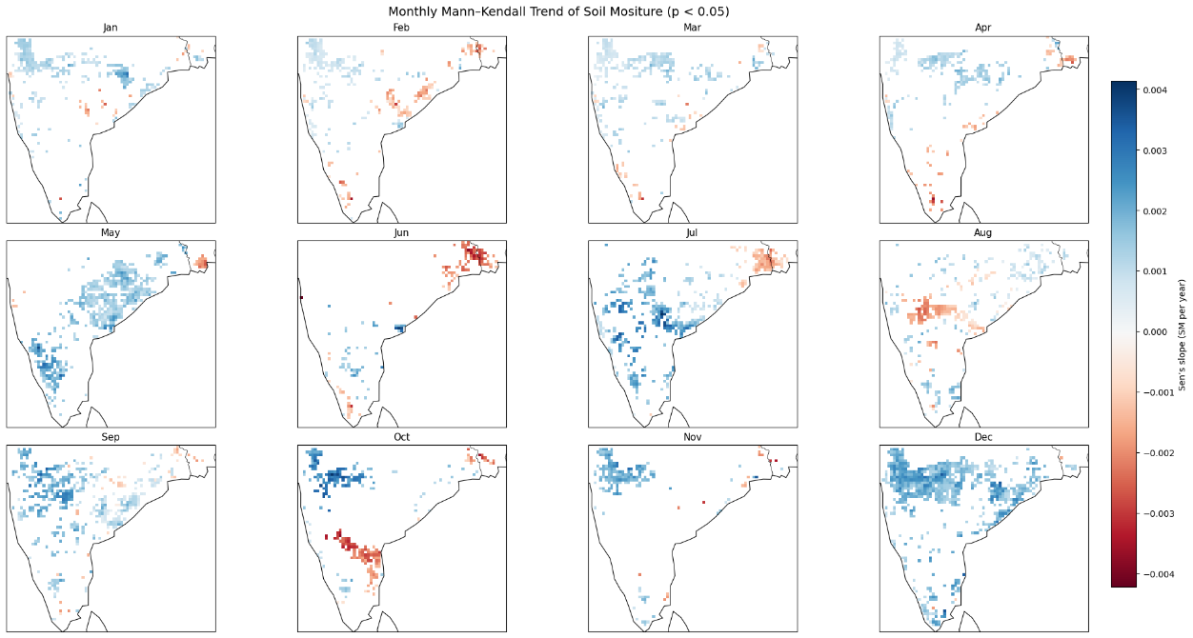
Figure 6 – Mann Kendall Mean Maps of Soil Moisture
Monthly mean soil moisture over Peninsular India shows a strong monsoon-controlled cycle, with low to moderate levels during January–March, pronounced pre-monsoon depletion in April–May, rapid recharge from June onward, and peak conditions during July–September. Moisture remains relatively elevated in southern and southeastern regions during October–November before gradually declining in December.
The Mann–Kendall analysis (2000–2024) indicates seasonally varying trends. Dry-season months show weak and scattered changes, while May exhibits localized increases. During the monsoon, July and September display increasing trends over western and central regions, with localized declines in August. Post-monsoon months show mixed behavior, and December reflects more widespread increasing trends, suggesting improved late-season moisture persistence.
Runoff:
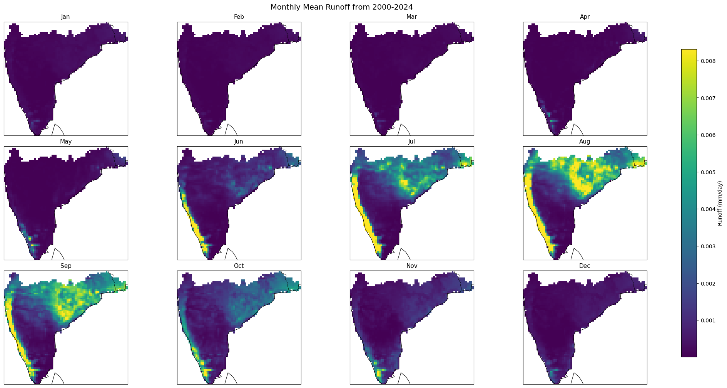
Figure 7 - Monthly Mean Maps of Runoff
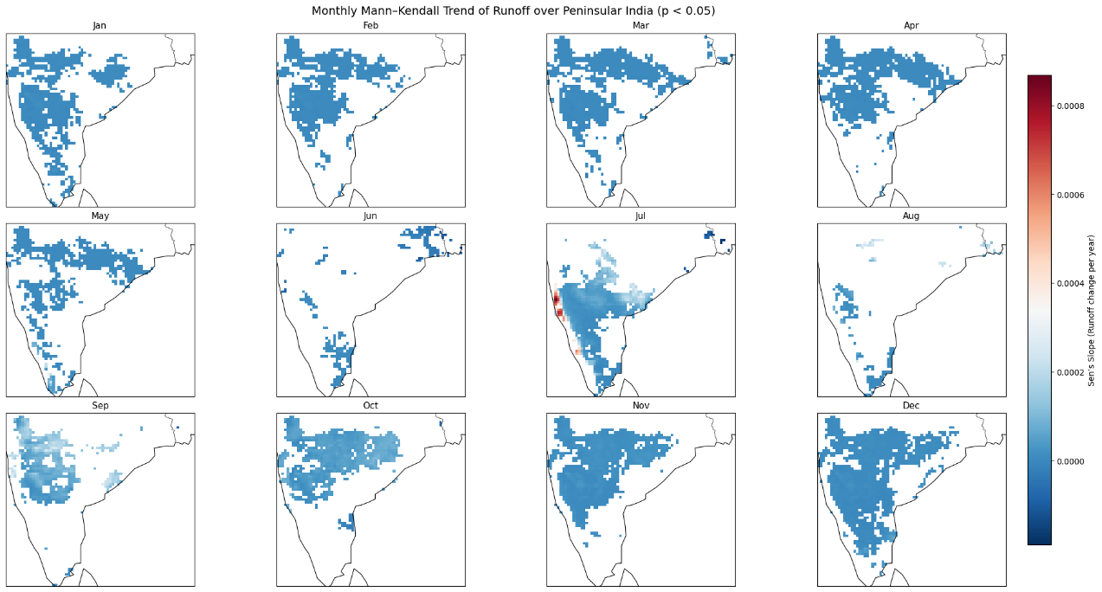
Figure 8 - Mann Kendall Mean Maps of Runoff
Runoff over Peninsular India exhibits a strong monsoon-controlled seasonal cycle. January–May show uniformly low runoff, reflecting dry-season conditions. A sharp increase occurs from June, peaking during July–September, with highest intensities along the western coast due to orographic rainfall and steep gradients. Runoff declines gradually from October and returns to minimal levels by December. Trend analysis indicates predominantly increasing runoff across much of the peninsula, particularly during dry and early pre-monsoon months. Monsoon months display greater spatial variability, with localized increases and minor coastal declines. Post-monsoon months again show broadly positive trends, suggesting a strengthening runoff response over the study period.
Groundwater:
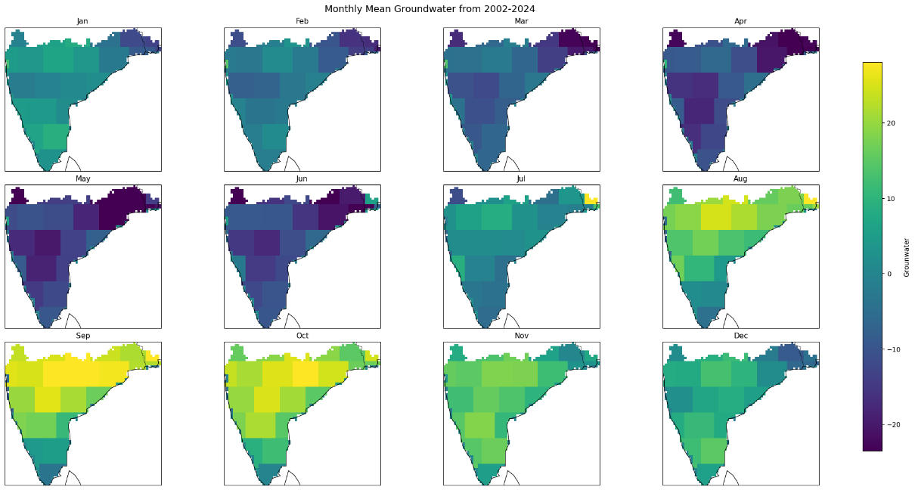
Figure 9 – Monthly Mean Maps of Groundwater
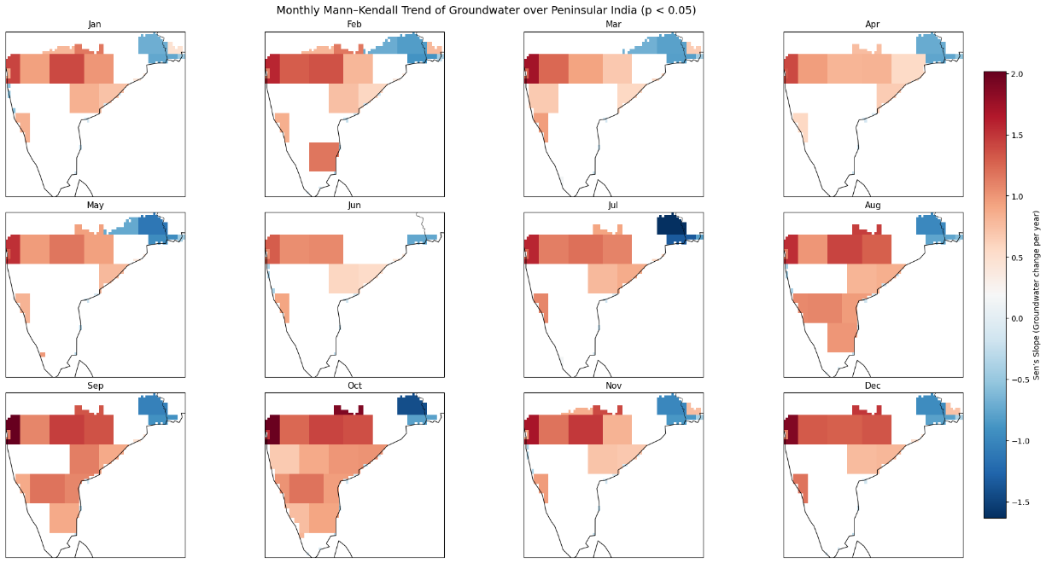
Figure 10 - Mann Kendall Mean Maps of Groundwater
Groundwater exhibits a clear seasonal cycle, with declining levels from January to May due to progressive dry-season depletion. Recharge begins with the southwest monsoon in June, and storage peaks during August–October across much of central and western Peninsular India. Levels gradually recede from November onward, reflecting reduced rainfall inputs and continued groundwater discharge. Trend analysis indicates predominantly increasing groundwater levels across central, western, and southern regions, especially during pre- and post-monsoon periods. Monsoon months show more spatially extensive positive trends, reflecting enhanced recharge. However, northeastern sectors consistently exhibit significant declining trends, highlighting localized depletion despite broader regional strengthening.

